**TASK23 - MYSQL**

**Task Description: Create a Table Empl to store employee details as shown below and write statement for following the queries based on table**

***Answer:***

**CREATE TABLE:** 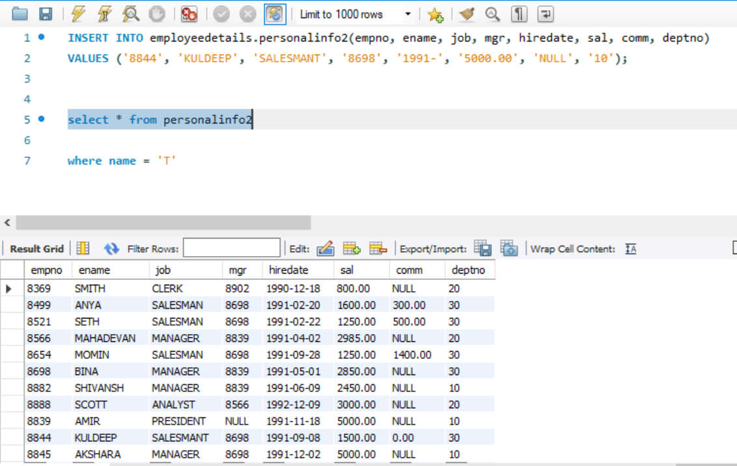



1. **Consider the Employee table and write SQL command to get the following.**
2. Write a query to display Ename and Sal of employees whose salary are greater than or equal to 2200?

***Answer:***

**Code:**

SELECT ename, sal

FROM personalinfo2

WHERE salary>=2200

**Explanation:**

1. First, we select the values to be displayed.
2. Second, we write FROM <table name> to get the attributes (columns) from the respected table name.
3. In the end, we write WHERE <condition>, to get only the salaries which are greater than or equal to 2200.

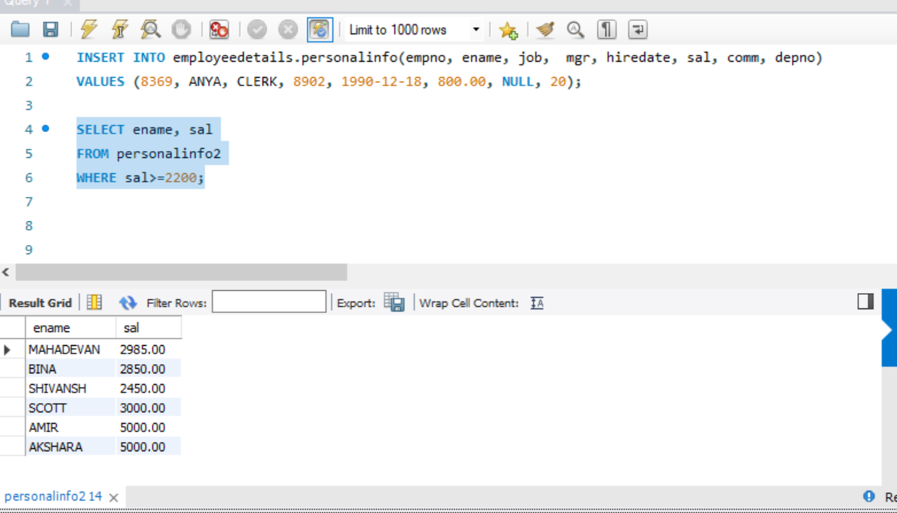

1. Write a query to display details of employees who are not getting commission?

***Answer***  
Select * from personalinfo2

Where comm is NULL

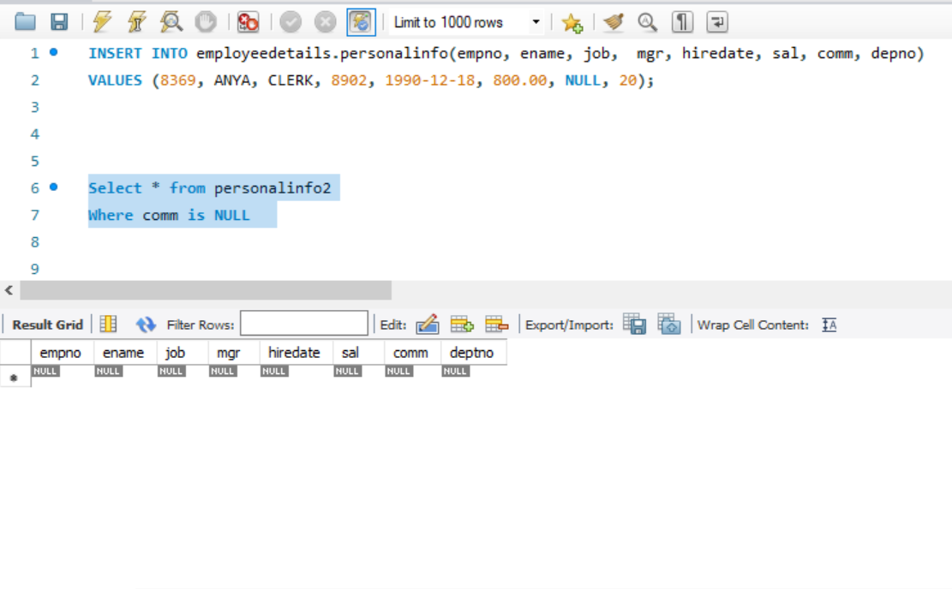

1. Write a query to display employee name and salary of those employees who don’t have their salary in the range of 2500 to 4000?

***Answer***

SELECT ename , sal FROM personalinfo2 WHERE sal NOT BETWEEN 2500 AND 4000;

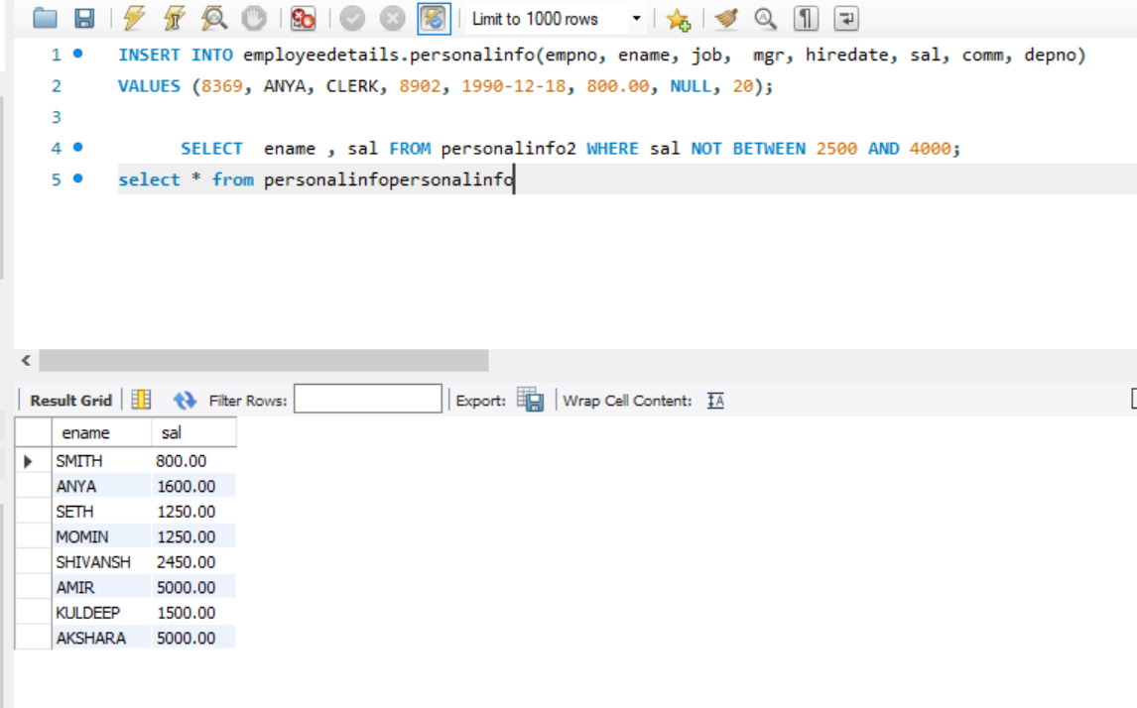

1. Write a query to display the name, job title and salary of employees who don’t have a manager?

***Answer***

SELECT ename, job, sal FROM personalinfo2 WHERE mgr IS NULL;

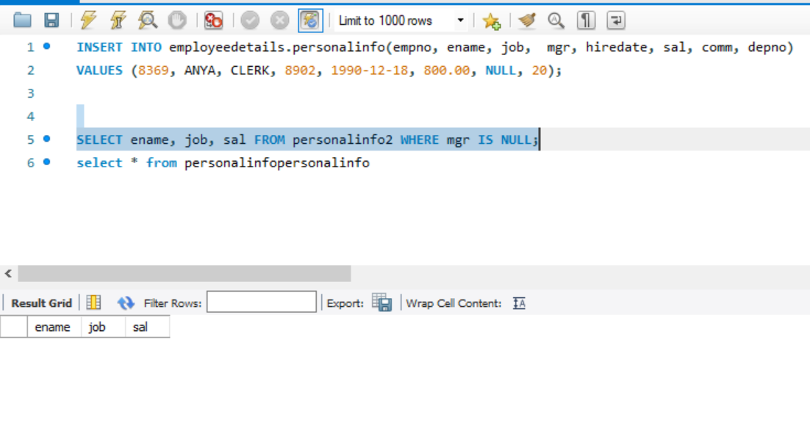

1. Write the query to display the name of an employee whose name contains “A” as the third alphabet?

***Answer:***

SELECT ename FROM personalinfo2

WHERE ename LIKE'__A%';

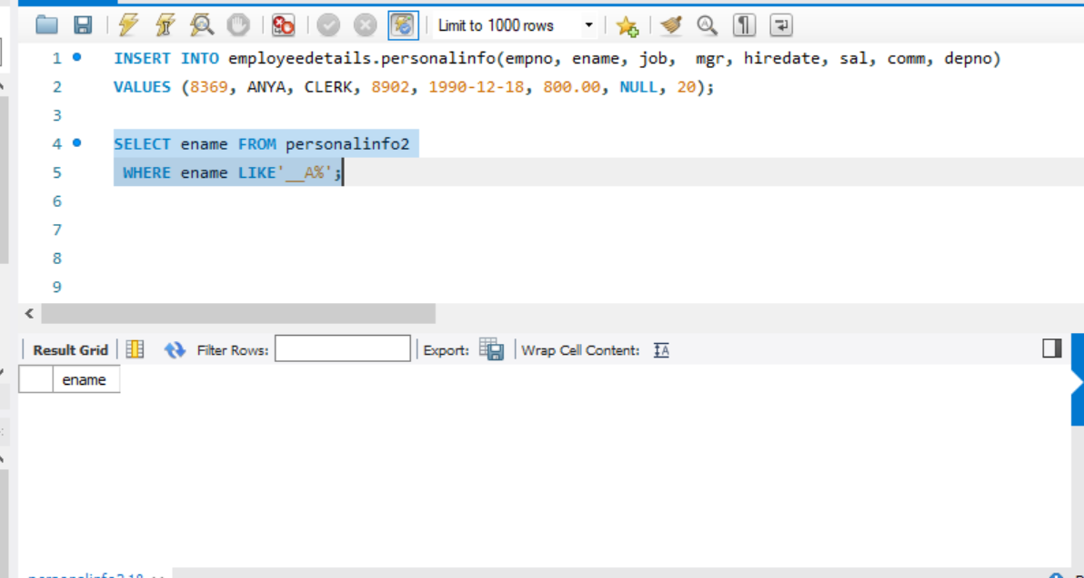

1. Write the query to display the name of an employee whose name contains “T” as the last alphabet?

***Answer:***

SELECT ename FROM personalinfo2

WHERE ename LIKE ‘%T’;



  